**CANKAYA UNIVERSITY**

**FACULTY OF ENGINEERING**

**COMPUTER ENGINEERING DEPARTMENT**

****

**CENG 407  
Innovative System Design and Development I**

**A LITERATURE SEARCH FOR PROJECT MANAGEMENT ASISTANT   
Version 1.0**

***Hakan İREN 201411211***

***Selçuk ATAGÜN 201411204***

***Advisor: Prof. Dr. Erdoğan DOĞDU***

**Word Count: 1201**

Contents

[Abstract 3](#_Toc482178659)

[1. What is a Project Management System ? 4](#_Toc482178660)

[1.1 Key Features of the Project Management Assistant 4](#_Toc482178661)

[1.1.1 Project Start 4](#_Toc482178662)

[1.1.2 Planning of the project 4](#_Toc482178663)

[1.1.3 Project follow-up and control 4](#_Toc482178664)

[1.1.4 Completion of the project 4](#_Toc482178665)

[1.2 PMA Benefits 5](#_Toc482178666)

[2. General System Architecture 5](#_Toc482178667)

[3. Module Dependencies 7](#_Toc482178668)

[4. Related Application 7](#_Toc482178669)

[5. System Overview 10](#_Toc482178670)

[Conclusion 11](#_Toc482178671)

[References 12](#_Toc482178672)

# Abstract

In this literature review, we present literature related to our Project Management System project. We will first introduce Project Management Systems (PMS). Secondly, we explain why the project management system should be used, its logic, properties, types and advantages. Due to PMS, even those who do not have high-level computer usage information without code knowledge can take tasks in important projects, undertake project follow-up and report projects. In addition, the system is based on web technologies, that for reason we can easily access the system anywhere in the world. In this literature, we will explain similar systems and what is used differently than these systems.

# What is a Project Management System?

The project management system is used to manage the project. Project management system is the planning, reporting and control of project activities to reach the project objectives. When these activities are carried out, it is necessary to stay within performance, cost, time limits and to keep project size within acceptable limits. Project management provides us installation, using, management and simple features make simple use without technical knowledge. [4]

The project management system we will do provide both of a single user and common users that collaborative system. A single user system is programmed with the assumption that one person will make changes at the same time in the project plan. Also common users can programmed project at the same time.

## Key Features of the Project Management Assistant

### Project Start

The starting part of the project is very important because if this step does not start correctly, the other steps will also be adversely affected. The PMA guides the user in the right way for the correct steps to be taken when starting the project and for the planning phase.

### Planning of the project

Errors in the planning phase will cause major obstacles to the success of the project, such as the start-up phase. For this reason, the PMA provides that important phase is done correctly by choosing who should be involved in the project, the role choices of the people involved in the project, and topics.

### Project follow-up and control

The control and observation phase consists of timely recognition of problems in the implementation of the project and timely corrective actions and procedures to control implementation. An important benefit of this phase is the difference in implementation from the project management plan through the monitoring and measurement of project performance.

### Completion of the project

It includes formal completion of the project. Administrative activities include archiving the files and documenting the lessons learned.

## PMA Benefits

* Easy reach to personal &projects information
* It offers objective tracking.
* Reducing paperwork
* It makes anyone a quick study.
* Easy communication between team members.

Besides these, there are many advantages of PMA web-based. These;

* Access to any type of computer without the need to install software on the user's computer
* Convenience in access control
* Single and multi-user
* One version and software to be maintained
* Central data warehouse
* Project information cannot be accessed when the user (or server) is offline.[3]

# General System Architecture

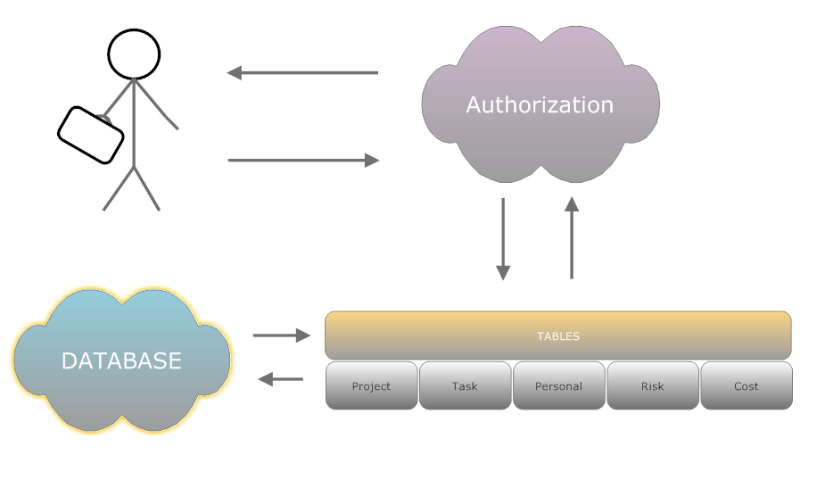**Figure-1:** System Architecture

# Module Dependencies

**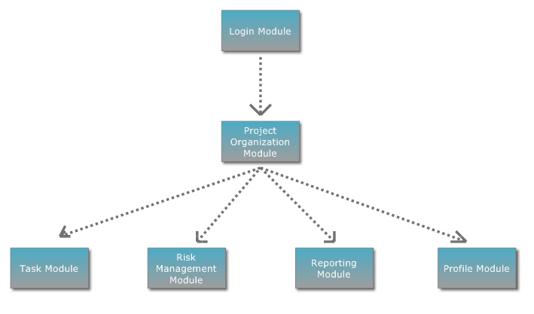**  
**Figure-2:** Module Dependencies

# Related Application

Redmine [1], Redmine is a web-based project management and bug tracking system software that is widely used all over the world. First released in 2006, Redmine is a free software that is an important part of the development infrastructure of tens of thousands of progenies in different sectors, especially computer software projects.

One of the most important features that distinguish Redmine from similar vehicles is that it offers extensive privatization possibilities. With Redmine, you can define and customize project-specific areas that have important functions in project management such as business records, business processes, user roles, wikis, and discussion areas

SebaPLUS [2] refers to Semantic e-Business applications, which enable you to manage all your activities that are important for carrying out your business through a single web-based system. You can use your company's internal activities and outgoing relationships in a single system Is the whole of the applications that enable you to make the institutional organization by allowing you to reach out to the executive from the one place where you want to report about your company.

In addition to the two similar programs we have compared above, there is a rewarding and punishment system in the project that we want to do. The aim of the systems is to directly contribute to the motivation and productivity of the operating personnel, to increase the satisfaction of the business so this system can be considered as an incentive program and a positive force for employees. For these reasons, the rewarding and punishment system that we use in our project makes a very important difference. Accordingly, project users who complete the project on the specified deadline and meet the requirements will be rewarded with premium or extra vacation. This prize varies according to the importance of the project. At the same time, there is a penalty for the project that does not finish on the specified date or is completed without meeting the requirements. This penalty will be given by the administrator. The penalized person will not be able to take part in subsequent projects or the roles on other projects will be limited.

|  |  |  |  |
| --- | --- | --- | --- |
|  | **Redmine** | **SebaPLUS** | **Project management Assistant** |
| Entering risks | C:\Users\Selcuk\AppData\Local\Microsoft\Windows\INetCache\Content.Word\21808151-3d-check-mark-icon-Stock-Photo.jpg | C:\Users\Selcuk\AppData\Local\Microsoft\Windows\INetCache\Content.Word\21808151-3d-check-mark-icon-Stock-Photo.jpg | C:\Users\Selcuk\AppData\Local\Microsoft\Windows\INetCache\Content.Word\21808151-3d-check-mark-icon-Stock-Photo.jpg |
| Updating cost and report | C:\Users\Selcuk\AppData\Local\Microsoft\Windows\INetCache\Content.Word\21808151-3d-check-mark-icon-Stock-Photo.jpg | C:\Users\Selcuk\AppData\Local\Microsoft\Windows\INetCache\Content.Word\21808151-3d-check-mark-icon-Stock-Photo.jpg | C:\Users\Selcuk\AppData\Local\Microsoft\Windows\INetCache\Content.Word\21808151-3d-check-mark-icon-Stock-Photo.jpg |
| Rewarding | C:\Users\Selcuk\AppData\Local\Microsoft\Windows\INetCache\Content.Word\ScreenHunter_1.bmp | C:\Users\Selcuk\AppData\Local\Microsoft\Windows\INetCache\Content.Word\ScreenHunter_1.bmp | C:\Users\Selcuk\AppData\Local\Microsoft\Windows\INetCache\Content.Word\21808151-3d-check-mark-icon-Stock-Photo.jpg |
| Task, role, time period assign. | C:\Users\Selcuk\AppData\Local\Microsoft\Windows\INetCache\Content.Word\ScreenHunter_1.bmp | C:\Users\Selcuk\AppData\Local\Microsoft\Windows\INetCache\Content.Word\21808151-3d-check-mark-icon-Stock-Photo.jpg | C:\Users\Selcuk\AppData\Local\Microsoft\Windows\INetCache\Content.Word\21808151-3d-check-mark-icon-Stock-Photo.jpg |
| Project Creation | C:\Users\Selcuk\AppData\Local\Microsoft\Windows\INetCache\Content.Word\21808151-3d-check-mark-icon-Stock-Photo.jpg | C:\Users\Selcuk\AppData\Local\Microsoft\Windows\INetCache\Content.Word\ScreenHunter_1.bmp | C:\Users\Selcuk\AppData\Local\Microsoft\Windows\INetCache\Content.Word\21808151-3d-check-mark-icon-Stock-Photo.jpg |
| Update personal information. | C:\Users\Selcuk\AppData\Local\Microsoft\Windows\INetCache\Content.Word\21808151-3d-check-mark-icon-Stock-Photo.jpg | C:\Users\Selcuk\AppData\Local\Microsoft\Windows\INetCache\Content.Word\21808151-3d-check-mark-icon-Stock-Photo.jpg | C:\Users\Selcuk\AppData\Local\Microsoft\Windows\INetCache\Content.Word\21808151-3d-check-mark-icon-Stock-Photo.jpg |
|  |  |  |  |

**Table 1 : Comparison chart**

# System Overview

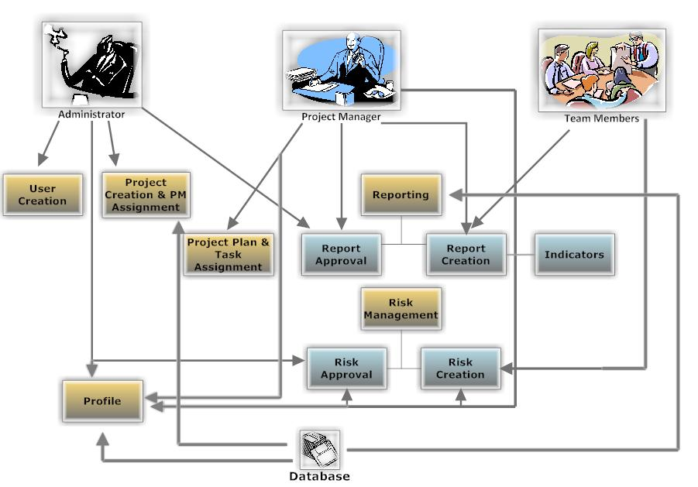**Figure-3:** How does project management assistant?

|  |  |  |
| --- | --- | --- |
| **Admin** | **Project Manager** | **Team Member** |
| * Project Creation * User Creation * Assign project manager | * Entering risks * Reject or approve new risk * Reporting risk * Update personal information * Task, role, time period assign. * Updating cost and report * Changing password. | * Report Creation & Forwarding * Enter new risk * Update cost information * Update personal information. * Change password |

**Table -2:** User Responsibilities

# Conclusion

During this research, we learned a lot about the Project management assistant Systems. We tried to answer a lot of questions about what this system is, what it does, what are the benefits, what your web development technology and features are, and what applications are related to them. By the general structure of the system, we tried to give information about project and project cycle management concepts and phases, the phases of project development and planning within the scope of logical framework approach, and how to evaluate the project proposals using criteria. Finally, we tried to explain the basic concepts used in project management together.

# References

[1] “Redmine Proje Yönetim Sistemi”, “Tanım”, Retrieved <https://ozguryazilim.com.tr/urunlerimiz/redmine-proje-yonetim-sistemi/> [05.05.2017].

[2] “sebaPLUS Nedir?”, “Neden sebaPLUS?”, Retrieved <http://www.sebaplus.com/tr/content/sebaplus-nedir/9> [05.05.2017].

[3] IEEE. IEEE Std 830-1998 IEEE Recommended Practice for Software Requirements Specifications. IEEE Computer Society, 1998

[4] “Mirosław J Skibniewski”, “Pollaphat Nitithamyong”, “Automation in Construction”, (27 February 2004), [07.05.2017]